1. Introduction to Module 2
▶️ Welcome to Module 2 (0:44)
In this week will move on into the topic of Statistical Learning. In particular will answer the question what is Statistical Learning? I will go through some techniques to assess model accuracy. Will end up the week by covering some extra Python code and I strongly suggest that you read Chapter 2 of this book An Introduction to Statistical Learning as well as work through the assessments. So let's go into the topic

2. Introduction to Statistical Learning
▶️ Intro to Statistical Learning (6:47)
We're going to start this chapter by briefly introducing the concept of statistical learning. To understand this idea, let me introduce you to a very simple example. Consider that we have historical data containing information about 200 marketing campaigns. For each campaign, we have the amounts invested in radio, TV, and newspaper advertisements. Also for each campaign, we know the resulting total number of sales. In this particular example, what we have is an output sales that we would like to predict using the three inputs, radio, TV, and newspaper advertisement. In other words, what we're trying to answer is the following question, how can we predict sales, the output variable using as input, the amount invested in the three sources that I mentioned before. In other words, we would like to have a function that approximates the output sales, as a function of these three arguments in here. In the picture below, you can see how sales in the y-axis relate to TV, radio, and newspaper advertisement. For example, in the first figure, we can pick a particular amount of investment, and look at the resulting average value of sales, for all the historical marketing campaigns that were around that particular investment level. Let me now introduce some of the notations we're going to use in the rest of this course. We're going to denote the vector of inputs by the capital letter X. This is going to be a vector containing X_1 to X_p inputs. These are going to be the input features that we will use to make predictions. Also, we will use the small bold letter case x to denote a particular value of this vector of inputs. Again, this is going to be a p-dimensional vector with x_1 to x_p entries. In the previous example, we have three particular inputs. The value of p, meaning the number of features or the number of inputs that we're using to solve our prediction, is going to be equal to three. Now we can also look at the particular structure that the vector X is going to take. In particular we are going to have X_1, X_2, and X_3 inputs. Again, p is equal to 3. X_1 can be assigned to the level of TV investment, X_2 can be the radio investment, and X_3 can be the newspaper investment. Notice that the capital vector X contain the variables that we're using as inputs. These are different than concrete values. To clarify the difference between the capital X and the small x, we can now look into a particular example so we can define a vector, a small x, containing three values. Therefore, if we say that capital X is equal to a small x, what this is indicating is that the first component of capital X, which is equal to TV, will be the same as a 1,000, meaning we're investing 1,000 units in TV. The second entry of capital X, which is radio, is equal to 800, so this is indicating that the investment in radio is 800 units. Finally, the third entry of X, is equal to the third entry of the small x, which is 900 units. By equating capital X to a small x, what we're really indicating is a particular value of all the inputs that we have in the vector X. Similarly, we will use the capital letter Y to denote the output variable, and a particular value of the output will be indicated by small y. In the previous example, our output variable is sales and we're going to assign the variable capital Y to sales. If we say that the small y, is equal to 2,500 and we equate capital Y to small y, what we're really saying is that sales is equal to 2,500 units, as we indicate at the end of this line. Let's now move on to a proper theoretical setup to study this statistical learning problem. In this course, we're going to assume that X is a vector of random variables, and Y is a scalar random variable. In the field of statistical learning, it's common to assume that the output variables are generated using what's called an additive model. This model has the form in this equation, essentially what this is saying is that the output Y, the value that we observe as the output of an experiment, is some function of the inputs plus an Epsilon value. Let me go into the explanation of each one of these elements. F is an unknown function that is called the regression function. This regression function will be a very important ingredient in this course. An Epsilon is what we call a measurement noise. This is going to be a random variable that we know has zero mean and variance Sigma square. For example, in the advertisement example that we had before. According to this model, what we have is that sales is equal to a function of the vector of inputs, so we're going essentially put them here together as radio, TV, and newspaper plus some measurement noise. Now, something that's very important for you to notice is that this regression function is something that's unknown to you. This is something that nature is using to generate the data that you observe in your experiments. Now, the statistical learning problem, which is stated before, is to estimate these unknown regression function using historical data, meaning random samples drawn from the additive model. Essentially f is unknown, you only have access to a data set, and what you really want to determine is what's this function f. What's the function that nature is using to generate the data, and this is a function that's unknown to you. A big part of this course will be to try to develop techniques in order to estimate f.

這段文字是統計學習（Statistical Learning）非常經典的開場白（通常出自知名的《Statistical Learning》教科書系列）。
它的核心目標是：教你如何用數學符號，把「用數據做預測」這件事標準化。
為了讓你輕鬆掌握，我把這段話拆解為三個層次：核心故事、數學符號、以及終極模型。

1. 核心故事：廣告與銷售量
這段話用了一個很直觀的例子：
- 你手上的數據： 200 場歷史行銷活動的資料。
- 輸入（原因）： 在「電視（TV）」、「廣播（Radio）」、「報紙（Newspaper）」投入的廣告金額。
- 輸出（結果）： 最終帶來的「銷售量（Sales）」。
我們想解決的問題：
能不能找到一個「公式」或「功能（函數）」，只要我輸入未來的廣告預算，它就能幫我預測出銷售量？

2. 數學符號：大寫 vs 小寫
在統計學裡，為了溝通精準，科學家定義了特別的符號。這段文字花了很多篇幅在解釋這個：
輸入變數（特徵 / Features）
- 大寫粗體 X： 代表「概念/變數本身」。它是一個向量（清單），裡面包含三個變數：
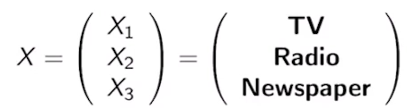
- 小寫粗體 x： 代表「具體的數值」。
- 當我們寫 X = x時： 代表把具體數字帶入概念中。
例子： 如果 x = [1000, 800, 900]，意思就是電視投 1000 元、廣播投 800 元、報紙投 900 元。
輸出變數（標籤 / Target）
- 大寫 Y： 代表你想預測的目標概念（在這裡是「銷售量」）。
- 小寫 y： 代表具體的銷售數字（例如：y = 2500 件）。

3. 終極理論：加性模型（Additive Model）
這是這段話最重要的一擊。統計學家認為，大自然在產生數據時，遵循著下面這個公式：
Y = f(X) + epsilon
我們來拆解這個公式的內部秘密：
- Y（看到的結果）： 實際觀察到的銷售量。
- f(X)（規律）： 這叫做回歸函數（Regression Function）。它是大自然隱藏起來的「完美公式」。只要輸入廣告費 X，它就能算出平均而言應該得到多少銷售量。
- epsilon（噪音 / Epsilon）： 這叫做測量誤差或雜訊。因為現實世界充滿隨機性（例如：剛好那天大下雨、或是對手剛好倒閉），所以即使廣告費一模一樣，銷售量每次也會有一點點卡住或跳動。
- 這個雜訊的平均值是 0。E[ε] = 0; Var[ε] = σ²

💡 總結：什麼是統計學習？
「大自然手上握有那個完美的公式 f。我們不知道 f 是什麼，我們手裡只有過去的歷史數據（X 和 Y）。
統計學習的目的，就是利用這些歷史數據，去『猜』、去『估計』出大自然手上的那個 f 到底長什麼樣子。」
只要我們猜得夠準（找到一個很好的 f 估計值），以後我們只要決定好明年的廣告預算 X，就能準確預測出銷售量 Y 了。

▶️ Regression Function (11:36)
In this video, I'm going to talk about some of the theory and practice involved in the regression function. Using tools from statistics, one can prove that the regression function is equal to this conditional expectation, essentially the expectation of Y given X. If we have access to the conditional pdf f of Y given X, we could compute this expectation by using the explicit formula that we introduced before. Essentially, we need to compute the integral of Y times f of Y given X, and the integration goes over Y. Notice, that once you do the integration over Y, this is a function of the bold X, the vector of concrete values of inputs. Now, something that you should realize is that in practice, it's typically impossible to have an explicit access to these conditional pdf. Also, using tools from optimization, one can prove that the regression function f is a function that is a solution to the following optimization program. Essentially, we want to minimize the expectation between the output variable and a particular function, g and we're going to look for a solution over the space of all functions g. Now, it turns out that the argument that solves this minimization is equal to the regression function. Something that's important to realize is that this expectation in here is called the mean squared error. If you think about it, the difference between Y and g of X, when g of X is some prediction function, is the error between the output and your prediction using the inputs. If you do the square of this, this is nothing but the squared error, and if you do the expectation, what you're going to get is the mean squared error. As I mentioned before, the solution of this optimization problem can be proved to be this optimal regression function, which is equal to this conditional expectation. Again, the proofs for these facts are beyond the scope of this course, and I will try to focus on the interpretation in the following slides. In the previous slide, we introduced some theoretical results concerning the regression function. Now, we're going to move on about some practical details that are important while estimating the regression function. In our practical setup, what we are going to assume is that we do not have explicit access to the conditional pdf f of Y given X, however we are going to have sample data from the additive model. Therefore, we can pose the statistical learning problem in practice as follows. We are given a dataset D, where this dataset contains n pairs of inputs and outputs. Essentially, this would be the first pair, and this would be the nth pair, and these are going to be the inputs, and these are going to be the output values. These are going to be random samples that are drawn from the additive model. Also notice that X_i is a vector. We're going to have p components, and this is the notation we're going to use. Essentially the kth component of X_i is going to be equal to X of iK. The first index will indicate the sample that we're dealing with, and the second index will indicate the entry of that vector. Our problem is then to find an estimate of the regression function f, and we'll denote our estimation by f hat. Now, let's look into the figure below. In this figure, I'm going to represent a dataset, assuming for simplicity, that p is equal to one. In other words, I have a single input X. The value of this input is represented in the x-axis of the figure and the corresponding output Y are in the y-axis of the figure. What we have in here is a scattered plot, where each point represents a data point in our dataset D. In particular, if we take a particular point, like the one marked in the figure, we're going to have that this point i will have an x-component, X_i and a y-component, Y_i. In this particular case, X_i is a scalar, but in general X_i should be a vector. Now, throughout this course, we're going to assume that this dataset D is generated according to the generative model that we'll describe below. In particular, we're going to have that the output Y_i is generated according to some unknown function of X_i plus a noise. We will typically have access to the statistical properties of this noise, in particular, we'll know that the expectation of this noise is zero, and that the variance of this noise is equal to Sigma squared, but we will not know the particular form of this function f. Therefore, our job will be to get an estimate of f, which we call f hat, using the dataset alone. Let's now look into a particular way in which one may be tempted to solve the statistical learning problem in practice. In this approach, we use the fact that the regression function f is given by the conditional expectation of Y given X. Now notice that the theoretical expectation can be numerically approximated using an empirical mean. Now, how would these empirical mean look like. Well, since we're conditioning on a particular value of x, something we can look at is the set of points for which the input x_i is exactly equal to x, and then compute the empirical mean of the outputs y_i corresponding to that set of points. This is essentially what we formally defined at the right. I'm going to define a set of points d_x. These are going to be the indexes in our data sets for which the input x_i is exactly equal to the value of x for which we want to make a prediction. Now, something that we can look at is the average of the outputs corresponding to the set of indexes in d_ x. How do we compute that? Well, this is essentially what we have in this summation. So we're going to do a summation for all the indexes in this set d_x, and I will sum over all the outputs y_i corresponding to inputs for which x_i is equal to x. To compute the empirical mean I'm going to finalize just by normalizing over the total number of points satisfying the condition in d_x. However, this approach is not very practical because if you look at that data set, the probability of finding points in d for which x_i is exactly equal to x is going to be very low. In particular, it's going to be very unlikely that you will find any point at all for which x_i is equal to an exact real value x. We can zoom in into this picture. So if you consider a value of x equal to two, for example, and you try to find points in the data set for which x_i is exactly equal to two, you will notice by looking into this zoom part of the image, that you will not be able to find any point for which x_i is exactly equal to two. You may be able to find points that are very close to x_i equal to two, but none of them will be exactly two. We need to come up with another approach to overcome this limitation. This approach is based on the technique presented in this slide. In particular, what we're going to do is augment our definition of the set of points that we will use to compute the empirical mean. So instead of considering points that are exactly a value x we're going to consider points in our data set that are close enough to the value of x. So what this expression is telling you is the following, the distance between a point x_i and a given point x is less or equal than r. I'm using this double-wall delimiters to denote the length of a vector. So if you look into the length of the vector x_i minus x, this is nothing but the distance between x_i and x. The expression below will indicate that x_i minus x is less or equal than some distance r. Now, we're going to define the set of points. This of r of x to the set of indices representing input points x_i that are a distance less or equal than r to a desired point x. Now you can notice that in this new average, what I do is a simple extension of what I had before. I'm going to compute the empirical mean of the outputs y_i in this set of points that are close enough to x, and then I will normalize over the number of points in that set. Now using this approach, we can overcome the issue of not having any point for which x_i is exactly x. In other words, if we choose an appropriate value of r, we will be able to find points in the data set that are close to our given vector x for which we want to make a prediction. So you can look at this figure. As we did before, we want to make a prediction for x equal to two. In order to do that, instead of looking at the points for which x is exactly equal to two, we're going to take a window. The width of this window is going to be two r. So essentially, r units to the right and r units to the left, and we're going to select those points that are inside this window here. So if we zoom in you can look in here that in this case we will have many points encircled by a red line that will be part of this set, this of r of x. Therefore, the empirical mean that we obtain should be close to the conditional expectation of y given x. Let me finalize this slide by providing some intuition of what we just done. Remember that the regression function is nothing but the expected value of y corresponding to a given value of x. So what this windowing process is really doing is looking at the set of points for which the input is close to this value of x, and looking at the empirical mean of the value of y. So in summary all we're doing is try to find an approximation of the theoretical expectation by using an empirical mean.

1 Attempt Quiz: Regression Function
這段是從「純數學理論」跨入「機器學習實務」的核心橋樑。
教授在這裡回答了兩個關鍵問題：
- 理論上，那個大自然完美的 f(X) 到底是什麼？
- 實務上，當我們只有一堆零散的數據點時，要怎麼在電腦裡把它算出來？

1. 理論層面：f(X) 的數學真面目
兩個數學工具（統計學與最佳化）來定義 f(X)：
觀點 A：條件期望值（Conditional Expectation）
在統計學中，完美的 f(X) 其實就是：
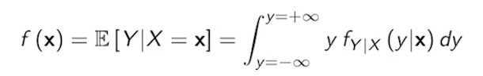
- 白話解釋： 當輸入的廣告費固定是 x 時，輸出銷售量 Y 的平均值（期望值）。
- 數學算式： 如果知道機率分布（PDF），可以用積分來算：。但現實中我們根本不可能知道這個完美的機率分布。
觀點 B：最小化均方誤差（Mean Squared Error, MSE）
在最佳化理論中，如果我們想找一個預測函數 g(X)，讓它跟真實答案 Y 的誤差平方越小越好：
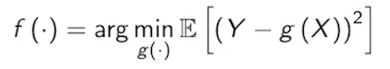
- 結論： 數學可以證明，能完美解出這個民生痛苦指標（最小誤差）的那個唯一答案 g(X)，正好就是 f(X) = E(Y | X = x)。

2. 實務困境：為什麼「精準匹配」行不通？
回到現實世界，我們沒有完美的無限數據或積分公式，我們只有一個包含 n 筆資料的點狀數據集 D = {(X_1, Y_1), (X_2, Y_2), ….., (X_n, Y_n)}。
你想用這堆點來估計 f(x)（我們寫作 hat{f}(x)，讀作 f-hat）。
嘗試一：找一模一樣的點來算平均（Empirical Mean）
你想預測當「電視廣告費 X = 2 萬」時的銷售量。你自然會想：那我把歷史資料裡所有剛好等於 2 萬的資料抓出來，把它們的銷售量 Y 加起來除以總筆數。
- 數學表達： 收集所有 X_{i} = x 的索引集合 D_{x}，然後算平均：
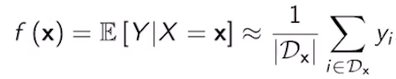
❌ 失敗原因：連續變數的詛咒
看影片中放大（Zoom in）的圖。在現實中，你想預測 X = 2 的地方，歷史資料裡可能只有 2.0001、1.9998，連一個剛好等於 2.00000...的點都沒有！ 找不到點，你就無法除以總筆數，這個方法直接卡死。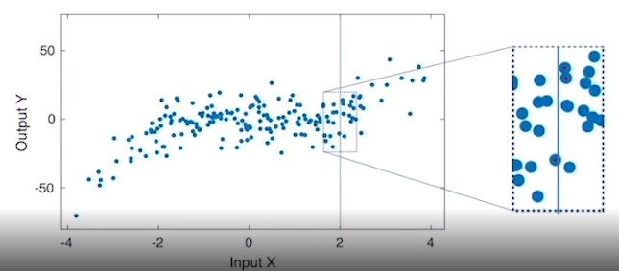

3. 實務解法：鄰近視窗法（Windowing / Nearby Points）
既然找不到「完全一樣」的點，那我們就找「夠接近」的點！這就是KNN（K-近鄰算法）或核心密度估計（Kernel Density Estimation）的雛形。
嘗試二：開一個窗戶（Window）
我們允許一個誤差範圍 r（半徑）。只要歷史數據 X_{i} 落在以 x 為中心、左右各寬 r 的窗戶內（也就是距離 ||X_{i} - x|| ≤ r），我們就把這些點抓進來！
- 新集合 D_{r}(x)： 所有跟目標 x 距離小於等於 r 的數據點。
- 新的估計公式 hat{f}(x)：
🎬 影像化的直觀理解
看教授畫的那張散佈圖：
- 你想預測 X = 2 的位置。
- 你以 2 為中心，往左往右各跨出 r 的距離，畫出一個垂直的帶狀窗戶（寬度為 2r）。
- 窗戶圈到了很多紅圈圈（歷史數據點）。
- 把這些紅圈圈的 Y 軸數值（銷售量）全部加起來算算術平均數。
- 這個平均數，就是你對大自然完美函數 f(2) 的實務估計值 hat{f}(2)！
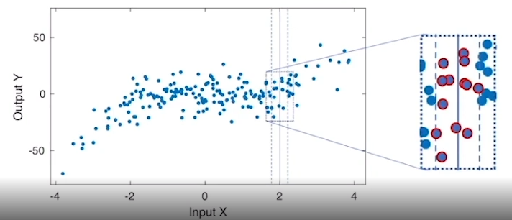

💡 這段影片的思維精髓
這段教學在幫你建立一個極為重要的機器學習直覺：
「機器學習在做的事情，本質上就是用『局部區域的經驗平均值（Empirical Mean）』，去逼近『理論上的條件期望值（Conditional Expectation）』。」
- 如果半徑 r 設得太大：窗戶太寬，會把不相關的遠方點也抓進來平均，預測會不準（欠擬合 / Underfitting）。
- 如果半徑 r 設得太小：窗戶太窄，抓到的點太少，平均值會被個別雜訊 epsilon 綁架，跳動很大（過擬合 / Overfitting）。
這個關於窗戶大小 r 的抉擇，就是後面章節會深入探討的重大課題。

▶️ Curse of Dimensionality (11:45)
Welcome back. In the previous set of slides, we saw how using local averaging, we could estimate the regression function f using local empirical average. So this is something that we are illustrating in this picture. So if we want to estimate the value of f of x, the regression function for a particular input x equal to 2, something that we can do is consider a narrow window of width 2r around that point. Look at the points that are contained in that particular window and then compute the average value. So if you look the average value of the Y's, meaning the heights of all these points, you'll get a prediction that will be somewhere in here. So looking back into the figure, we'll get a point that's somewhere in the middle of that cloud of points. If we repeat this process for a moving window, what we're going to get is essentially a function that crosses the cloud of points somehow in the middle of the cloud. So using this local averaging, we could estimate the regression function f of x just using these empirical average that this here represented by the green line. The next question is therefore, are we done with this course? So as I mentioned at the beginning, the main problem to tackle in a statistical learning theory is to find the function f of x, so are we done? So we're going to argue that this is not the case because a phenomenon called the curse of dimensionality. The curse of dimensionality is an issue that appears when the number of inputs in your problem is much greater than one. So this is something that cannot be illustrated in the example with imploding in the slides, because in that case, p is equal to 1. However, we'll see that when p is much greater than one, points in the data set tend to be far away from each other. Therefore, local averaging is not going to be a feasible option. To illustrate the curse of dimensionality, we're going to consider different scenarios for the increasing values of p. So we'll start with p equal to 1, and we'll consider N points randomly distributed over a set S_1. So this is a one-dimensional set that is the interval between minus one and one. These points we are going to represent as blue dots, so we'll have N of those points uniformly distributed. We will also consider a particular value of x in that set that we are representing as a red dot. Now we want to answer the following questions, which is, how many points would you expect to have in the window D_r(x), when r is a small number. Remember that D_r(x) is essentially a window of width 2r around the point x. Now notice, that since we are throwing blue dots uniformly at random, the number of points falling into this set is going to be a random number. In order to get a concrete answer, we'll deal with the expectation of that number of points that we'll have in that set. This is what we described in this particular expression. So this is going to be the expectation, the expected value of the number of points in D_r(x). Since points are uniformly distributed in the set minus one to one, we have that the expected number of points on the line per unit length is going to be equal to N divided by 2, meaning the number of points on the segment divided by the length of the segment. To compute the expected number that we obtain in the window D_r(x), we can multiply that value by the length of the segment D_r(x), which is equal to 2r. So this is essentially the answer that we are getting here and after simplification, we obtain that the expected number of points that we get in the window D_r(x) is in expectation N times r. In what follows, we can increase the value of p. So lets consider now p equal to 2. In the case of p equal to 2, we're going to look into N points that are randomly distributed on a circle of radius one, and we're going to denote that set by S_2. I'm going to very quickly plot that set in this slide. So this is a circle where the radius is equal to one, and we will consider N points randomly distributed inside this circle. As we did before, we will take an arbitrary value of x, any point inside the circle, and also we'll build the set D_r(x), which in this case is a small circle surrounding the red dot. The question is now, what is going to be the expected number of points that will fall within that green circumference? As we did before, we can look into the density of points. So the density of points inside the blue circle, is essentially the number of points divided by the area, and this is the expression that we're having here, essentially N points divided by Pi, which is the area of the blue circumference. Now we can multiply that density of points per unit area by the area of the green circle, which is equal to Pi r squared, where r is the radius of the small circle. After simplifying the expression, we find that the expected number of values inside that circumference, the green circumference, is Nr squared. So when we go from p equal to 1 to p equal to 2, we go from Nr to Nr squared. We can now keep asking the same question for a large generic value of p. So in this situation, we're going to define a p-dimensional hypersphere of radius r centered around zero, and this is essentially defined by the set S_p, which is just all the points such that the magnitude of x equals or is less than r. So this is equivalent to the circumference that we had before but in high dimensions. Something that we should know about the volume of this hypersphere is that is given by an expression of this form. So essentially is a constant case of p that depends on p, the particular form of this constant is not relevant for us. So we're going to put under the rug. Something that is important though is that the volume scales as r to the power of p. So this is something that's going to be very relevant in our mathematical derivations. As we did before, we're going to consider N points distributed uniformly at random in the set S_p1. So this is the hypersphere of radius one centered around zero and we will consider a particular point x inside that hypersphere. So for example, for p equal to three, we will have a sphere, so let me draw it this way, so this would be a plot of the sphere with a radius equal to one and we will also consider a point x inside that hypersphere. As we did before, we will build another hypersphere centered around the red dot, which is x for us, and we will build a hypersphere of a small radius r, around that point. So the radius of that hypersphere is going to be r. Now the question is, if we have N points distributed uniformly at random in the large hypersphere, how many points do we get in expectation inside the small hypersphere? To answer this question, we can follow the same logic as we had before. The first step would be to find the density of points in the large hypersphere. So this is going to be equal to the number of points N divided by the volume of the hypersphere of radius one, which we know is equal to K_p times 1 to the power of p. So this is essentially just K_p, and we will multiply by the volume of this small hypersphere, which is K_p times r to the power of p. So you can see that the constant K_p is not important because it cancels out and now the answer of the expected number of points inside the small hypersphere is nothing but N times r to the power of p. So you can see that this is consistent with the previous results for which for p equal to one, we got N times r, for p equal to two, we got N times r square and for the generic p, we get N times r to the power of p. In other words, we have N random points in the large hypersphere, we have N times r to the power of p points in the small hypersphere. This is going to be very important in our following analysis. We're going to illustrate our results with the following simulation. Consider 1,000 random points in the sphere as S_p1, meaning that p dimensional hypersphere of radius one, and then count the number of points within a distance r equals 0.1 from any point x inside the hypersphere and repeat this process for p equals one to dimension five. In order to estimate the expected value, we're going to repeat 100 times for each value of p and compute the empirical mean and the standard deviation. In the figure below, you have the results of the simulation and we compare the empirical mean with the equation that we had before. So essentially, if you remember, the expected number of points was given by N times r to the power of p. So if we have 1,000 points, this is going to be 1,000 times r, 0.1 to the power of p, which is a function that decrease exponentially as p increases. This function is plot as a red line in this figure. In the same figure, we also plot the result of our numerical validation in the blue line. So you can see that both the blue line, meaning the empirical mean and the red line, which is a theoretical values, are very close to each other. The most important part of this experiment though, is not to check that our empirical value matches the theory, but to see how as p increases, the number of points inside a ball of radius r decreases dramatically at an exponential rate. Therefore, when we are dealing with a problem in which the number of dimensions p is very, very large, meaning the number of inputs in our problem is very, very large, the number of points contained in any small hypersphere centered at a point x is going to be extremely low. In practice, for p very,very large, the number of points will be practically zero. As a conclusion, if we want to do local averaging with a small r, we won't have any point inside our local window, which in the p-dimensional case will be a local hypersphere. Therefore, we will have data to average around any point x.
1 Attempt Quiz: Curse of Dimensionality

這段影片帶出了機器學習領域中，最令人聞風喪膽、但也最經典的核心概念：維度的詛咒（The Curse of Dimensionality）。
教授在這段話裡完美解答了一個轉折：既然上一節課學到的「開窗戶算鄰近平均（Local Averaging）」這麼厲害，那我們這門課是不是可以提早下課、宣布完結了？
答案是：不行。因為一旦輸入的特徵數量 p變多，這個方法會瞬間「破產」。
我們用教授在影片中展示的數學與模擬實驗，來一步步看懂這個詛咒是怎麼發生的。

1. 數學推導：點數量的「指數級崩塌」
教授做了一個實驗：在大範圍（半徑為 1）的空間裡隨機撒下 N個藍點，然後在一個小範圍（半徑為 r，例如 r=0.1）的窗戶裡，計算預期能抓到幾個點。
隨著維度（特徵數 p）的增加，這個小窗戶裡的期望點數發生了驚人的變化：
- 1 維空間 (p=1)： 資料是一條線。大區間長度是 2（-1到 1），小窗戶寬度是 2r。
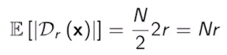
- 2 維空間 (p=2)： 資料是一個圓。大圓面積是 π 1²，小圓面積是 π r²。
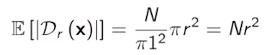
- p 維空間 (通用)： 資料變成高維超球體（Hypersphere）。大超球體體積與 1^{p} 成正比，小超球體與 r^{p} 成正比。
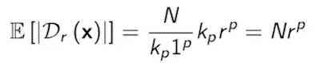
💡 關鍵結論
小窗戶能抓到的點數量，公式是 $N r^p$。
注意那個 p是在指數（次方）的位置！

2. 模擬實驗：當 N = 1000, r = 0.1時的慘劇
影片中教授跑了一個模擬，我們直接帶入數字，看看當維度 p 增加時會發生什麼事：
維度 p | 理論公式：1000×(0.1)^{p} | 窗戶裡剩幾個點？
p = 1(只有電視廣告) | 1000 x 0.1 | 100 個點 (還夠算平均)
p = 2 (電視 + 廣播) | 1000 x 0.01 | 10 個點 (有點勉強了)
p = 3(電視+廣播+報紙) | 1000 x 0.001 | 1 個點 (根本沒得平均)
p = 5(更多行銷管道) | 1000 x 0.00001 | 0.01 個點 (空空如也)
這就是影片中那張「紅線（理論）與藍線（模擬）一起垂直下墜」的圖表所表達的意思。
當維度 p 到了 5 的時候，小窗戶裡預期只能分到 0.01 個點。這意味著在現實中，你打開窗戶，裡面高機率是一片死寂，連一個點都沒有！

3. 核心問題：為什麼不能把窗戶 r 開大一點？
你可能會想：「既然點不夠，那我就把窗戶半徑 r 從 0.1 放大到 0.8 啊！」
這就是機器學習最糾結的兩難：
- 如果窗戶 r保持很小： 裡面沒有半個點，你沒辦法算平均，演算法直接卡死。
- 如果硬把窗戶 r擴大： 為了抓到足夠的點，你的窗戶必須開到超級大，結果把「離目標很遠、根本不相關」的歷史資料也抓進來一起算平均。這會導致你算出來的根本不是「局部（Local）」平均，預測結果會變得極度不準確（這在後面會學到，叫做高偏誤 High Bias 或欠擬合 Underfitting）。

🎯 總結：高維空間是個「孤獨的荒漠」
這段影片的精髓可以用一句話總括：
「在低維度有效的『鄰近平均法』，在高維度空間會因為資料點彼此變得極度遙遠、空間呈指數放大，導致周圍根本找不到鄰居可用。」
這就是為什麼我們不能只學 Local Averaging。當我們要處理現實世界中幾十個、甚至幾百個特徵（p 很大）的機器學習問題時，我們必須放棄這種單純依賴鄰居的方法，轉而去尋找其他能「強加某種結構」的模型（例如：線性迴歸、神經網路等）。

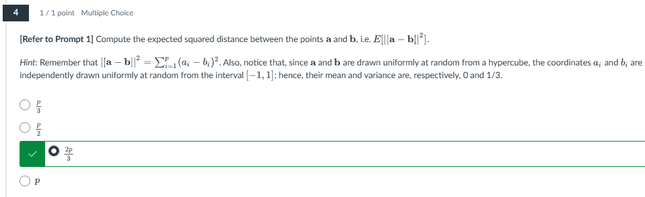
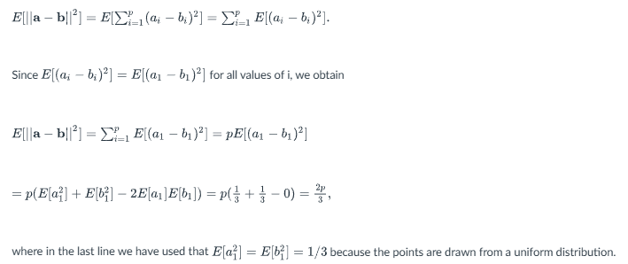

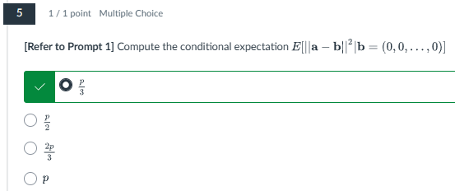
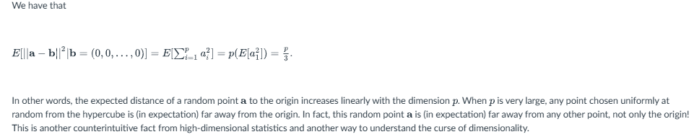
3. Statistical Models and Model Quality
▶️ Parametric Models (4:42)
Welcome back, in the previous video we discussed the curse of dimensionality. Briefly, when the number of inputs p in your problem is large, the curse of dimensionality does not allow you to use local averaging around a point x to estimate the regression function f(x). The mathematical description of this phenomenon can be observed in this figure. In particular, we can see that as p increases, the number of samples in any ball would shrink exponentially. Therefore for p very, very large, which are most real problems, we won't have any sample to use for local averaging.
In this situation, we'll need to come up with alternatives in order to beat the curse of dimensionality.
A particular approach that we'll be using in this course is the use of parametric models.
In a parametric model, we will approximate the regression function f(x) using a function f(x) hat, where we will have some free parameters theta. This is a vector of parameters that we will need to learn from data. A classical example of parametric model are linear models. So in a linear model, we have a function f sub l that takes as an argument x, and as a collection of three parameters we're going to have beta, so beta plays the role of theta above. And the shape of this function is equal to a constant plus a constant time the first feature in our entry times another constant times the second feature in our entry. And we keep going until we get to the last feature in our vector of entries. Remember that our vector of entries has p dimensions, x1 to xp.
Therefore, xi in the equation above are not samples, but the components of the input vector x. Once we have a parametric model such as the linear model above, we can estimate the parameters beta i using the observations in the dataset D.
We will denote the estimated parameters that were obtained from data as beta sub i super hat. Therefore, we can approximate the regression function using the estimated linear model, which we will denote by f sub l super hat.
The only difference between f sub l and x sub l super hat is that the parameters beta 0 to beta p has substituted by beta 0 hat to beta p hat, essentially the parameters that we obtained from data.
The main reason why this model does not suffer from the curse of dimensionality is that to estimate the parameters beta i, we need to make use of the whole dataset D, not only a small number of samples containing a ball of radius r, surrounding the point x.
Apart from linear models, we have a large variety of parametric models. So in here we have a short list, starting from the linear models that you probably already know, polynomial models, regression trees, that we will cover in this course, as well as support vector machines. For example, for p=1, we can simply build a polynomial model using the expression that you have below. So in this model, we have a constant alpha 0, plus another constant multiplying the input x, plus another constant multiplying the square of the input x, plus, we keep going until we get to the diff power of the input. So in this particular case, what we really have is a polynomial fitting of degree d. In the figures below, I show a polynomial fitting using a cloud of points that we saw before. So we see that for d=2, we essentially fit a parabolic shape passing through the cloud of points. For d=3, we fit a cubic function, that makes a better job at passing through the middle of the cloud of points. So this seems to be a good candidate to approximate the true regression function that nature is using to generate that cloud of points.
For d=20, we'll get a function that's very wiggly, essentially will go somehow through the middle of the cloud of points. But it will wiggle around those points, which is an undesirable effect called overfitting. We'll talk more about overfitting in the next set of slides.

這段影片是機器學習中「思想轉型」的關鍵。它帶你從前面受挫於「維度詛咒」的局部平均法（K-NN / Windowing），正式跨入現代機器學習的霸主——「參數模型（Parametric Models）」。

1. 為什麼局部平均死掉了？（複習維度詛咒）
前面幾題的幾何推導（空心球、兩點距離變無窮大）在實務上的後果就是：
當特徵維度 p 很大時，如果你在某個預測點 x 周圍畫一個半徑 r 的球，裡面根本抓不到任何歷史數據點。 沒有點，你就無法算平均數，這意味著非參數的局部平均法在真實的高維問題中直接宣告陣亡。

2. 救星登場：什麼是參數模型（Parametric Models）？
既然不能「看鄰居算平均」，科學家想出了一個大膽的假設：我們直接去「猜」大自然公式的『形狀』！
我們假定大自然的函數 f(x) 遵循某種特定的數學結構，這個結構裡有一些還不知道數值的「旋鈕」，這些旋鈕在數學上叫做參數（Parameters，通常寫作 θ 或 β）。
大自然: h(x)
parametric model: ĥ(x;β)
經典範例：線性模型（Linear Model）
教授舉了最經典的線性模型為例。我們直接猜大自然的規律是一條直線（或超平面）：
- 注意： 這裡的 x1, x2, …., xp 不是指第幾筆資料，而是指同一個輸入向量裡面的各個特徵分量（例如：x1 是電視廣告、x2 是廣播）。
- 參數 βi：這就是我們要透過歷史數據去調整的「旋鈕」。
為什麼參數模型能打破維度詛咒？
「因為要決定這些 β 旋鈕轉到哪裡，我們不需要在點 x 周圍畫圈圈找鄰居，而是動用『整張資料集 D』的所有數據一起來投票！」
當我們把所有資料丟進電腦，算出一組最佳的參數後，我們就把這組數字加上一個「帽子」, 最終得到的預測公式就是：
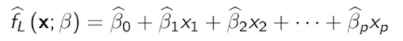

3. 多項式模型的抉擇：從多項式看「過擬合（Overfitting）」
除了線性模型，還有很多參數模型（如迴歸樹 Regression Trees、支持向量機 SVM）。教授用簡單的單維度（p=1）多項式模型（Polynomial Model），展示了模型複雜度（Degree d）對預測的重大影響：
當我們改變最高次方 d（這也是一種調整模型複雜度的旋鈕）時，會發生三種不同的幾何現象：
- d = 2（二次方 / 拋物線）： 畫出來是一條平滑的拋物線。它能抓到大致的趨勢，但可能有點太過簡單（有點欠擬合 Underfitting）。
- d = 3（三次方 / 立方曲線）： 曲線能非常完美、自然地從點雲（Cloud of points）的正中間穿過去。這通常就是我們在找的黃金預測函數（完美猜中大自然的規律）。
- d = 20（二十次方）： 因為次方太高，這條曲線會變得極度敏感與扭曲（教授形容為 Wiggly）。它為了討好每一筆歷史數據，會硬扭過去硬碰每一個點。雖然它在「歷史數據」上的誤差是 0，但這個形狀已經完全瘋了，只要隨機雜訊 epsilon 跳一下，它的預測就會大翻車。這就是機器學習中最著名的惡夢——過擬合（Overfitting）。
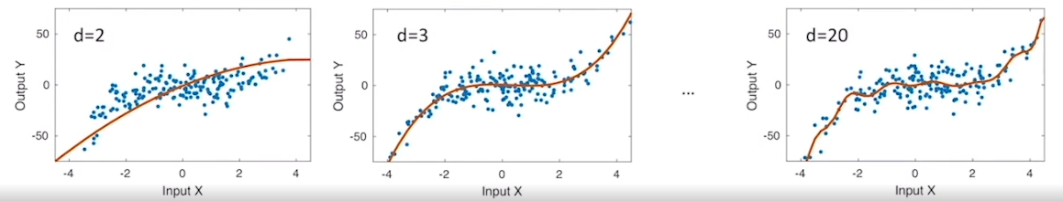

💡 這段影片的思維精髓
- 局部平均法（如 KNN）：不預設形狀，完全依賴局部鄰居（靈活，但卡死在高維度）。
- 參數模型（如 線性、多項式）：先預設數學形狀，用全體數據算參數（能抵抗高維度，但如果一開始形狀猜錯，例如大自然是彎的你硬要用直線擬合，預測就會爛掉）。

▶️ Model Quality (6:14)
Welcome back. We'll start this video by mentioning a few points about the process of assessing model quality. When working on a practical learning problem, for example, a machine learning problem, we should differentiate between two types of data. On the one hand, we have the Training dataset that we denote by D_Tr. This data set contains N training points that are available while estimating the unknown parameters Theta of the parametric model and the consideration. Remember, we denote this parametric model by f hat. Once we train the parameters of this model, the training mean squared error is given below. In particular, the mean squared error of the training process is defined according to this formula. Essentially, we have N points, so we're going to normalize with the factor 1 over N, and then we're going to have a summation over all the pairs of points X_i, Y_i in the training data set of the terms included inside the summation. This is an error between the real value of the output Y_i and the predicted value that my parametric model makes for this particular value i. We then take those errors, square them, and compute the empirical average, which we'll call the mean squared error. In contrast, we also have a testing dataset that we denote by D_Te. In this case, we have M testing points, and this is data that your learning algorithm has not seen during training. We can use this data to estimate the performance of future predictions using what we call the test MSE. The test MSE is defined in the expression below. In this case, since we have M testing points, we're going to normalize by the factor 1 over M. The summation is going to be over all the points in the testing data set, and the expression inside the parentheses is going to be identical that the one we had before. Essentially, is going to be the error between the actual value of the output and the predicted value of the output for a given input X_i. After squaring these values, the summation and normalization spits out the mean squared error for the testing datasets. In practice, the test MSE is a better reflection of the performance of our model. In this slide, we illustrate the difference between the training and the testing MSE. In particular, we're going to consider two different cloud of points. On the left-hand side, we have a cloud of points representing the training dataset, while on the right-hand side, we have the testing dataset. Both cloud of points have been obtained from the same additive model. In particular, we're going to assume that each sample X_i, Y_i, in any of these two figures, are coming from the same joint pdf. In the figure at the bottom, we compute the train and test MSE for the family of polynomials of degree 1-8. In this figure, we plot in blue the evolution of the train MSE as the degree of the polynomial increases. We can observe that this function decreases monotonically as the degree increases. This is a universal feature of the training MSE that can be explained from the fact that as we increase the degree of a polynomial, we are able to fit better and better a given training set. In the same figure, we plot in red the evolution of the testing MSE as we increase the degree of the polynomial fitting. We observe that in this particular case, the function is not monotonically decreasing, but it presents a minimum for a degree d equal to three. This indicates that a cubic polynomial would be the best choice out of the hierarchy of polynomial functions considered in this experiment. In this slide, we have a few comments about the training and test MSE. In particular, we have a conceptual figure below, describing the evolution of both training and test MSE as a function of the flexibility of a hierarchy of models. In the gray plot below, we plot the evolution of the training MSE as a function of the flexibility of the model. These flexibility is a generalization of the degree of a polynomial. Essentially, is a measure of how flexible a function is to follow a collection of points in a dataset. In the same figure, we also plot the test MSE in red. As we had before, the test MSE is not monotonically decreasing, but it presents a minimum at a particular value of flexibility. Since the test MSE is a measure of the performance of our model for future predictions, this is the exact level of flexibility that we should choose to train our model. In particular, when we have a level of flexibility below the optimal level, the parametric model f hat is not flexible enough to learn the regression function f faithfully. This would be the situation of these two points in here. In contrast, when we are above the optimal flexibility level, the model f is too flexible and starts following the noise in our training data. Essentially, the wiggle that we observe in the polynomial of degree 20 in our example we saw a few slides ago. This would be the case of the green squares in this part of the curve. Finally, the blue squares represent the values for the train and test MSE at the optimal level of flexibility when the test MSE is minimized. Again, this is the level of flexibility that we should use to train our model.
機器學習最精華的實務靈魂——「如何評估一個模型的好壞？」以及「如何找到完美的模型複雜度？」
這裡建立了一個極其重要的觀念：我們在學微積分或推導公式時，目標都是把誤差降到 0；但在機器學習裡，把訓練誤差降到 0 通常是一場災難。

1. 兩種數據集與兩種 MSE 公式
教授首先把數據切分成兩個完全獨立的世界。它們都是從同一個大自然規律（相同的機率分布）生出來的，但命運完全不同：
訓練集（Training Dataset, D_{Tr}）
- 目的： 拿來給模型「看」和「學習」的歷史考卷。總共有 N 筆資料。
- 訓練均方誤差（Train MSE）：
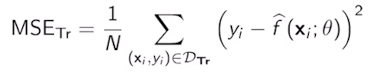
  - 白話：模型在已經寫過的考卷上，平均寫錯了多少分。
測試集（Testing Dataset, D_{Te}）
- 目的： 絕對不能讓模型提前看到的「模擬考題」。總共有 M 筆資料。用來測試模型真正的預測能力。
- 測試均方誤差（Test MSE）：
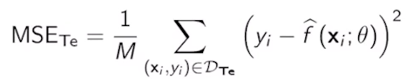
  - 白話：模型在完全沒看過的新考卷上，真正表現出來的實力。
關鍵結論： 在實務上，Test MSE 才是我們唯一在乎的指標。Train MSE 再低都沒用，因為那可能只是死記硬背。
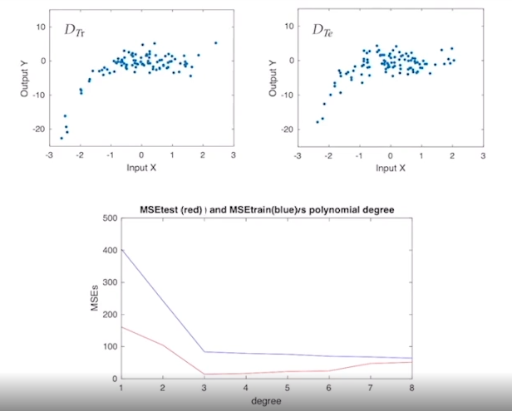

2. 隨模型靈活度（Flexibility）改變的魔幻曲線
當我們改變模型的靈活度（Flexibility）（例如：多項式的次方 d$從 1 次一路開到 8 次、20 次）時，Train MSE 和 Test MSE 會畫出兩條截然不同的曲線：
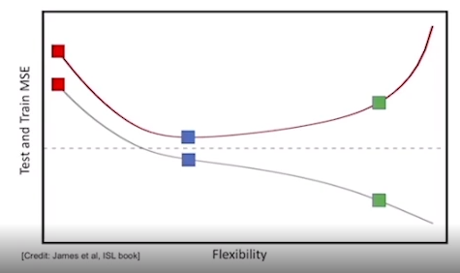
灰色曲線：訓練誤差（Train MSE）
- 行為： 隨著模型越來越靈活，曲線單調遞減（Monotonically decreasing）。
- 原因： 這是一個通用物理特性。多項式次數越高、參數越多，模型就越有能力去硬貼、硬套那些訓練點。當你開到無窮大時，模型甚至可以完美穿過每一個訓練點，讓 Train MSE 變成 0。
紅色曲線：測試誤差（Test MSE）
- 行為： 它不是直線下降，而是呈現一個 U 字形（具有一個最低點）。
- 原因： 一開始模型太笨，Train 和 Test 預測都很爛；當靈活度剛好時（例如影片中的 d=3 三次方），Test MSE 達到完美最低點。但當模型變得太過靈活時（如 d=20），它開始去硬背訓練集裡的隨機雜訊 epsilon，導致它在面對全新的測試集時，預測大翻車，Test MSE 瘋狂彈升。

3. 三種機器學習的境界
教授用這兩條曲線把模型狀態精準切分成三個層次：

狀態 | 靈活度位置 | 特徵 | 物理意義
欠擬合 (Underfitting) | 低於最優點  (橘色/左側) | Train MSE 高  Test MSE 高 | 模型太死板，連大自然基本的規律 f(x)都學不起來。（例如拿直線去擬合曲線）
最佳狀態 (Optimal) | 最優點  (藍色方塊) | Train MSE 低  Test MSE 最低 | 這是我們的終極目標。 模型完美學到了大自然的規律 f(x)，並且自動忽略了雜訊 epsilon。
過擬合 (Overfitting) | 高於最優點  (綠色方塊/右側) | Train MSE 極低  Test MSE 飆高 | 模型太聰明也太過靈活，連無意義的隨機雜訊（Wiggle）都背了下來，喪失了對未來的泛化能力（Generalization）。

💡 總結：統計學習的決策核心
這段影片揭示了整個機器學習領域最核心的賽局：尋找黃金分割點。
寫程式的目標絕對不是去盲目追求「在 Training Data 上的準確度達到 100%」。相反地，你必須拿一組獨立的 Test Data（或驗證集），一邊調整模型的複雜度，一邊盯著 Test MSE 的 U 曲線。
當 Test MSE 降到最低點、正準備反彈的那一個瞬間，立刻收手——那裡就是大自然真理的所在。
這個「Train/Test 分離」與「U 型曲線」的觀念非常直觀卻極度重要。

▶️ Bias-Variance Tradeoff (8:01)
In this slide, we present a theoretical framework to explain the shape of the test MSE. We start with a training data set D Tr formed by endpoints drawn uniformly at random from an additive model described in the equation below. Essentially, we're going to have a points xi that are drawn uniformly from a marginal distribution f(x), and then we'll compute the corresponding output y sub i, as a function f of x i. So, this is essentially the evaluation of the regression function, at the random point xi and we will add a measurement error epsilon, where this error follows a PDF, absolute epsilon. Again, remember that the function f is unknown, and nature uses this function to generate the data set. In order to estimate this unknown regression function, we're going to consider a parametric function f hat, where we have a vector of three parameters theta, and our task is to find the optimal values theta hat, that minimize the training MSE described in the equation below. In particular, this part of the expression is nothing but the train MSE, and this part of the equation tells us that we need to pick the value of theta that minimize this train MSE, and we'll save that value in theta star. Using that particular value of theta star, grouped in a trained model, by substituting theta by theta star in the parametric function that we had before. Using this trained model, we want to analyze the corresponding test MSE. In particular, consider a new data point that is drawn uniformly at random, from the joint pdf induced by the additive model, and this point has not been used in the training process. An alternative way to theoretically write the test MSE, is the expectation that we have below. Essentially, we can look at expectation for any random point x0 or y0, drawn from the additive model, off the squared error between the actual value of y0, and the predicted output using the trained model f hat evaluated with a parametric vector theta hat. Notice that, since x series a random variable, this function is also a random variable, and the quantity inside this bracket is a random variable. Therefore, we need to use the expectation to obtain a particular value of the test MSE. Using the statistical tools, one can prove that this test MSE, can be expanded in three terms, a variance term, a bias term, and a variance of the measurement noise. We have below explicit expressions for the bias term, and the variance term in particular, the bias term is the difference between the expected value of f hat, evaluated with theta star, meaning the optimal trained model. Minus f at x0 which would be the predicted value if we somehow were able to know the regression function that nature is using to generate the data points. We also have an expression for the variance at the bottom of this slide, and the variance follows the exact definition of the variance that we saw in the probability review slides. Since you're going to have the expectation of the random variable for which we want to compute the variance, minus this dictation x squared. So remember again that the function f hat, evaluated at theta star is a random variable because x0 is a random point.
The sum of the first two terms in the expansion of the test MSE, is what's called the reducible error, since this error can be reduced by choosing a good parametric function f hat. In other words, this error depends on what function f hat, which is to fit our model and can be minimized if we use f hat equal to the true regression function, that nature is using to generate the data. In contrast, the last term in the expansion of the test error, is called an irreducible error, because that term will always be there, even if we choose an f hat exactly equal to the regression function that nature is using to generate the data. An important observation is that the two terms in the reducible error, depend on the flexibility of the parametric model, used to train from data. In particular, the bias term decreases monotonically as the flexibility of the model increases. We can see this evolution in the cyan plot, at the bottom of this slide, in contrast, the variance term increases monotonically, as the flexibility of the model increases. This evolution is represented in the orange plot at the bottom of the figure. Finally, this dashed line represent the variance of the measurement error, which we call the irreducible error. Finally, the red line, is the result of summing these three terms, and we observe that we obtain a convex function, with a minimum at an optimal value of flexibility indicated by this arrow.
We can illustrate the bias variance tradeoff, using different polynomial fittings, in particular we're going to consider polynomials of degree 1, 3, and 20. And for each degree, we will generate ten independent cloud of points and fit the polynomials to those cloud of points. We observed that for b equal to 1, which is the figure in the left, all the linear polynomial fee things are very close to each other. This is the result of having a very rigid model, that's unable to change as a cloud of point changes. As a result, the variance of this model is low, but the bias is high. If we go to the cubic case for d equal to 3, we obtain a good fit to the middle of the cloud, indicating that the level of flexibility for cubic polynomials is at the right amount. Also we have that the variance and the bias of the cubic case, are both low. Finally, we can consider a very flexible model of degree 20, in that case, we can observe in the figure that the fitting wiggles around the cloud of points, this is an indication of too much flexibility in our model, corresponding to the case in which the bias is low, but the variance is high.
So, this week we have covered some very important topics in statistical learning theory. We started with the definition of the regression function, and the illustration of the curse of dimensionality, then we move on to the use of parametric model, and ways to assess model uncertainty, as well as the bias variance tradeoff. We're now moving on to two videos covering more python syntaxes. And as I did before, I suggest that you read chapter two in this book, and go through the course assessments, so I'll see you in the next video.

1 Attempt Quiz: Bias-Variance Tradeoff

這是整個統計學習（Statistical Learning）理論中最經典的期末必考大魔王——「偏誤-變異數權衡（Bias-Variance Tradeoff）」的數學拆解。
它用嚴謹的數學公式，完美解釋了為什麼前面看到的 Test MSE 會呈現那條神祕的 U 字形（凸函數 / Convex Function）。

1. 終極數學大拆解：Test MSE 的三胞胎
教授用統計學工具證明了，我們在未知新資料點 (x0, y0) 上的 Test MSE，可以被完美地切成三塊不同的靈魂：
$$\text{Test MSE} = \text{Bias}^2(\hat{f}(x_0)) + \text{Var}(\hat{f}(x_0)) + \sigma^2$$
這三塊各有其深刻的幾何與物理意義：
① 偏誤的平方（$\text{Bias}^2$）
- 數學含意： $[E[\hat{f}(x_0)] - f(x_0)]^2$
- 白話解釋： 「人類猜測的平均世界」跟「大自然完美真理 f」之間的本質距離。
- 特性： 模型越死板（Flexibility 低），Bias 就越高；模型越靈活（Flexibility 高），Bias 就越低（因為靈活的模型很容易貼近真理）。
② 變異數（$\text{Var}$）
- 數學含意： $E[(\hat{f}(x_0) - E[\hat{f}(x_0)])^2]$
- 白話解釋： 當你換了不同的訓練資料集時，你算出來的 $\hat{f}$ 形狀跳動、不穩定的程度。
- 特性： 模型越死板，大家的直線都長得很像，Variance 就極低；模型越靈活（次數開到 20 次），數據稍微變一點曲線就瘋狂亂扭（Wiggle），Variance 就飆得極高。
③ 不可約誤差（$\sigma^2$ / Irreducible Error）
- 數學含意： 大自然雜訊 varepsilon的變異數。
- 白話解釋： 還記得你前面親手算過的那題嗎？即便你拿到了完美的 f_2(x) = x^2 去預測，依然會留下一個由隨機雜訊帶來的 $\frac{4}{3}$ 誤差。這部分是人類無論怎麼優化演算法都絕對無法消除的硬傷。
- 可約誤差（Reducible Error）： $\text{Bias}^2 + \text{Var}$。這兩項是我們可以透過調整模型靈活度（選擇好函數 $\hat{f}$）來人為控制的。

2. 三條曲線組合成的 U 型賽局
教授在投影片下方展示了一張非常經典的幾何圖形。如果你把這三條線隨模型靈活度（Flexibility）的變化畫出來，你會看到：
- 青色線（Cyan - 偏誤 Bias）： 隨著靈活度增加，單調下跌。
- 橘色線（Orange - 變異數 Variance）： 隨著靈活度增加，單調上升。
- 水平虛線（Dashed - 雜訊 $\sigma^2$）： 橫在最下方，定海神針，永遠不變。
當我們把這三條線垂直相加（$\text{Bias}^2 + \text{Var} + \sigma^2$）時，神奇的事情發生了：
在左邊，被高 Bias 拉上去；在右邊，被高 Variance 拽上去。最終相加出來的紅色總體 Test MSE 曲線，被逼出了一個完美的凹口向上（Convex）的 U 字形！
那個 U 字形的最低點（箭頭指向處），就是 Bias 與 Variance 達到完美恐怖平衡的最優靈活度。

3. 10 份雲端數據的經典實驗（度數 1, 3, 20）
為了讓你直觀體會，教授做了一個極具啟發性的實驗：生成 10 組獨立的數據集，分別用 1 次、3 次、20 次多項式去抓規律。
- $d = 1$（直線世界）： 你把 10 條直線疊在一起看，發現 10 條線長得幾乎一模一樣。這代表低變異（Low Variance），模型非常穩定。但因為大自然的真理其實是彎的，這 10 條直線離真理都很遠，這代表高偏誤（High Bias）。
- $d = 20$（瘋狂扭動世界）： 你把 10 條 20 次方曲線疊在一起，發現每條線都長得完全不一樣，有的往天上去、有的往地底衝，這代表模型極度不穩定，高變異（High Variance）。但如果你把這 10 條瘋狂曲線在某個點上的預測值取平均，它們的平均值居然會非常接近真理，這代表低偏誤（Low Bias）。
- $d = 3$（黃金比例）：
10 條曲線既不會長得太離譜（Low Variance），又都能自然地從數據正中間穿過去（Low Bias）。這就是我們要找的平衡點。

💡 學習大總結：你已經修完了統計學習的第一核心章節！
這段獨白是這門課理論部分的完美句點。你從一開始學會用數學符號 $(X, Y)$ 描述問題，歷經了：
- 發現局部平均會被維度詛咒殺死。
- 於是轉身投靠參數模型（如線性模型），用全局數據算參數 $\hat{\beta}$。
- 為了評估模型，把數據切分成 Train / Test，發現了 Overfitting 現象。
- 最終用 Bias-Variance Decomposition，從數學底層徹底看穿了 Overfitting 的罪魁禍首。

4. Python Lab
▶️ Python Introduction 2 (10:20)
So in this cell, we introduce how to define functions but we are you going to use def to define functions. For example in here, we're going to define the function foo. Notice that in the definition of the function, we're not using curly braces like you use in C. Instead, we can use indentation to delimit blocks of code. So in here, we are going to define the function foo. We're going to put a colon to get into the definition, and the function foo simply print the string, Hello world. So if you have foo, you will get us an output Hello world. You can also define a function that we can call add that takes two arguments, x and y, and brings the result of x plus y. So if you run the function, add 2, 4, you will get six. You can even define functions with four variables.
Now, something that's interesting in Python is that you can assign a function to a variable and pass it around. For example, in this cell, we define the function foo that returns x plus 20, essentially just adds 20 to whatever argument you feed into the function foo. Now, you can assign the function foo to a variable mystery and pass it around. So essentially, mystery of 80 will be foo of 80, which is 100, meaning 80 plus 20. We can define another function that takes f, whatever you put in the argument and we'll return f with an argument one. So if you apply to one mystery, what this is going to do is it's going to plug mystery in f and return mystery evaluated at one. Remember that means steady is equal to foo and foo sums 20 to the argument. Therefore, what's going to happen is the summation of 20 to the argument one and output will be 21. So this is a bit convoluted, but I invite you to think about what the output is. Also, there is a very convenient way to define functions in Python using Lambda. Essentially, we can define very conveniently if function in the form Lambda x, take an x plus 1. So this is a function that takes x and sum nine. So essentially, if you take that as the argument of applied to one, what's going to happen is that the function applied to one is going to take this function defining here as the argument, plug it in there and apply with the argument x equal to 1. So essentially, the output will be 1 plus 9, which will be 10. So bottom line, whenever you see Lambda in the code, what this is really defining is a function, where you have the argument following Lambda and after the colon, you have the definition of the function, which is notationally very convenient. Also notice that instead of using Lambda, you can define a function with def. For example, the function doubles that doubles an argument and use that as an input to the function applied to one. Therefore, this function applied to one can take another function as an argument.
We can also define tuples using parentheses, this are like lists but we cannot modify the content, and if you try to change the content of a tuple, you will get an exception from Python. So I invite you to look into the code in this cell. We can also define dictionaries, which are key value data structures. So for example, we can define an empty dictionary using the curly brackets. We define the dictionary grades using curly brackets and using column to pair inputs and outputs. Therefore, you can just call the dictionary by using the name of the dictionary and using as an argument the input of a particular line, you can check the existence using in, and I invite you to check the rest of the code, which is quite straightforward.
So let's move on to control flow and exceptions. So these are very important in our course. Essentially, we're going to start with the if else blocks. So in here what you have the typical if else control flow syntaxes. So you can say if one is greater than two, which is not true, then you use colon and message will be defined as the string. If one is greater than three, which is not true, message will be defined as a string, and else meaning if nothing of the above applies, message will be defined with this string and also you can have ternary if then else in a single line. We can also define y loops. So essentially we are going to start with x equal to 0, and while x is less than 10, you print x followed by the text is less than 10, and then you sum 1 to x. Essentially, this is similar to the C code where you take x, sum 1, and save the result into x. We also have for loops. So essentially we have the loop for x in the range 10. So essentially from 0 to 9, you can print x and you will go from 0 to 9 as you have in this output. Also you can use continue and break. Continue will skip one iteration and move on to the next iteration and break will essentially jump out of the loop. We now move on to list comprehensions. This is a very neat way to generate lists in Python. So the best way to understand this is by looking at the examples. So essentially, you can define the list powers of 2 as 2_x for x in the range 0 to 9. You can also add condition else inside the list comprehension to get more complex lists. Finally, you can also put ternary operations in the comprehension.
So I invite you to read this cell about generators as well as specialization. So something that's interesting is the map and filter. So essentially, we can define a function double that simply returns the input. So essentially we have an input argument x, we will obtain 2 times x. Now we can define a list 1-4. Now, what map does is takes a function double and apply the function to all the elements of the list. Now the list will generate a list with those outputs and will save the values in twice_xs. So if you bring twice_xs, you're going to get the double of the elements in the original list. So this is simply a way to apply a function to all the elements of a list. So you can skip this line. We can also use map to use this with multiple lists. So for example, you can define the function mult that takes two arguments, x and y, and returns the multiplication. You can define pairwise products as the map of the function mult when the arguments are two list, 1, 2, 3; 4, 5, 6. So remember that mult takes two arguments and multiply them. So when you feed two list, what's going to happen is you're going to get the point-wise operation. Meaning the point-wise product of 1 times 4, 2 times 5 and 3 times 6 and then we'll save those into a list. So the outputs will be, 1 times 4 4, 2 times 5 10, 3 times 6 18. Now based on pairwise products, you can now define the dot product, which is a dot product or the inner product of two vectors, which is nothing but the sum of the multiplication applied to two lists. So that's why we need to include mapping here. So the dot product of 1, 2, 3, 4, 5, 6 is going to be 1 times 4 plus 2 times 5 plus 3 times 6, which is the inner product, and this is equal to 32. You can also use filter to filter out the elements of a list satisfying certain logical conditions. For example, you can define the logical condition is even of x that will be true if x is even as defined in this condition. Now, you can take a list xs and you can apply the filter is even to xs. So essentially what this filter is going to do, is going to filter out the elements of xs for which the function is even. Therefore, out of the numbers 1 to 4, you will only get the even numbers that will be 2 and 4 and the result will be included in a list that we can print in the same line. Now finally, the command reduce is going to combine the elements of a list as follows. So we can define a list 1 to 4, we're going to define a multiplication operation, which is simply takes two arguments and returns a multiplication. Now, you can reduce the multiplication operation on the list xs, and what's going to happen is reduce is going to multiply 1 times 2, which is 2, and then combine these two elements and reduce them into one. Meaning, we'll remove the 1 and then we'll take 2 and multiply it by 3, is going to be 6. So the resulting list is going to be 6, 4 and then we'll take 6 and multiply it by 4. Therefore, if you apply reduce to the multiplication of xs, what you are going to get is the product of all the entries in this list. So this finalizes the second week of this course. Next week, we'll move into the topic of linear regression. I'm sure that many of you are familiar with linear regression, but this is a very simple setup in which we can introduce some of the concepts that will be covered in more depth throughout the course.

▶️ Python Introduction 3 (10:00)
In this video, we're going to briefly cover the use of Pandas in the Python programming language. In pandas were going to store data in a data structure called DataFrames or Series. So you seen this first line, we're going to import the pandas library, the second line, the input numpy, is to import a library for numerical computation. And the last one matplotlib is to import libraries for data visualization. We're going to start by loading the data set essentially in this line in here, we'll load the data set. This data set is related to real estate information. We're going to essentially just keep the columns where intercept in and reordered them in order to have the price in the last column.
So by taking a look at this data set, we see that in the first column we have the index indicating the row. In here we have the address or the particular house in the real estate portfolio, we have number of bedrooms, number of full_bathrooms, half_bathrooms, the type of home, the size in a square feet the lot size and finally the price. In the next cell, we sensually illustrate several ways to see the size of our data frame. We can use print df.shape to reindicate the number of rows and the number of columns in our data set. We can also print the number of rows by using these two lines and in the last two lines we also count number of rows by ignoring the NaN numbers essentially missing entries in both address or lot_size. So essentially we don't have any entry with missing size, but we have quite a few entries in which we don't have the lot_size.
The .head command is very useful to have a quick visualization of the first five entries of our data frame so we can get an idea of the content.
In this cell, we're now going to remove some instances where either there is no value for the number of bedrooms or for the number of bathrooms, or the square footage is 0 or the lot size is not a number, meaning the missing entry. After filtering the data set by removing these instances, this rows what we're going to have is 4,058 remaining entries, meaning remaining rose in our data frame.
In the next cell were going to replace the NaN numbering half bathrooms with a 0 and in the next one we find the smallest livable service.
In the next cell were going to normalize the units in the area, measured in lot sizes. In particular, we have some units that are used in a square feet, some others are using acres and we want to compare everything to square feet.
And you cannot check in the resulting data frame that the lot sizes are normalized to square feet.
We're now going to take a look at the groupby function and check what he can do. In particular, we're going to start by grouping by type of property. So if you see that result of this cell, essentially we're going to have a count of the number of units for different types. So we have Condo/Townhome, we have Mobile Homes, Multi-Family Home and essentially we have here account of the different types of homes in our data set. We can also group by the number of bedrooms. We can also plot the count versus the number of bathrooms and here you can rename the column that is indicated here by 0 by account, which is visually more appealing. Now a convenient feature of data frames is that they have a built-in plot function.
Using the code in this cell, you can directly plot a histogram of the number of units as a function of the number of bedrooms.
Using this cell, you can just call groupby an size to return the series. So essentially in here you're going to have a serious of the Condo/Townhouse type and you will get a serious index by the number of bedrooms, same for Mobile Homes for Multi-Family Homes, Single Family Homes, and so on and so forth. Finally, we can convert this the previous series to a data frame just by using pd.DataFrame of S and in here will get a data frame containing the time series that we had before.
In this cell we reset the index and change the column names, and finally we're going to shuffle the rows for the case, we want to separate this into training and testing data sets. So this is something that will be important in coming lectures.
In this line. We're going to save these into an SQL database and then give an example of reading our data from the database. Essentially, you can see in this cell, an example about how to read from the database.
And now we can move on to Pandas indexing. Again, I know that I'm going very fast for these cells. The whole point is to give you just a quick preview of this particular notebook. And I strongly suggest that you spend some time going through the cells and trying to understand what each line of the cell is doing. Now moving on to Pandas indexing, we're going to create an example data frame about a fictional army. So in here we have the type of regiment, so we have night hawks, dragons and so on and so forth. We have different companies, number of deaths, number of bottles and so on and so forth. And now we can plot the first few lines of this artificial data set using dot head.
If you want to count the number of entries classified by origin, you can use the F of size and the output will be return as a series. If instead of a series you want a data frame, you can just use the double square bracket. You can also select multiple columns by including two arguments in the double square brackets. And you will get the output as the data frame. We're now moving on to the loc command. So in the loc command, you have two arguments in the bracket following .loc, the first one index rows, the second one indexed columns. In this cell we are using the loc command with a colon. Whenever you see a colon, this indicates that instead of picking a particular row, you're going to pick all the rows in that particular data frame. And then size will indicate that you're going to focus on the column size. So this will return a data frame containing all the entries of any row associated to the column size.
You can also select multiple columns the same way. If you use the loc with a particular entry, what you're going to get is a series as an output. If you want to get a data frame, you should use the double square brackets.
You can also select rows with the same name and you can also use multiple rows with a specific column. So you can have Arizona and Georgia in the rows and the columns will be size and deaths. Essentially, the result would be this three by two data frame in here.
You can also use the iloc command which is used to index by position. So if you want to extract the first column in the data frame, you should use a zero in the index of the columns. Remember the indexes in Python start by zero. So if you use zero, is really indexing the first column in the data frame also consistent with what we have seen before. A single square bracket return the result as a series and a double square bracket would return it as a data frame. Again, you can select multiple columns by using multiple inputs in the second argument.
And you can also select the first row by using 0 in the argument using a single bracket. Again will give you a list. Double bracket will give you a data frame. Now moving on to selecting multiple and specific rows and columns. You can select a two by two table containing the first and second row and the first and second column and getting the result as the data frame. You can also select a particular range by using colon. Essentially this will take you in the range 2*4 and the range 0*4. Remember then the index 2*4 will pick from index two which is the third entry to the index four minus one, meaning index three which is the fourth entry. So this is something that can be a bit counter intuitive. So I invite you to experiment with those indexes for you to get a grasp on indexing in Python. Okay, so this is what I have to say about this particular notebook. Again, I invite you to go carefully through this lines so you can get a better understanding of what each line of code is doing. And this will be something important throughout the course. Essentially almost every week we'll have some Python homework that you will have to solve. The intention is for you to get familiar with how to analyze and manipulate data via Python using Pandas and NumPy.

Lab 1 Materials

